# Communicate with friend

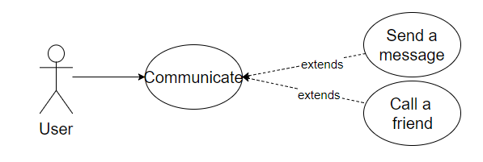

## Characteristic Information

|  |  |
| --- | --- |
| Superior business process: |  |
| Goal: | The user communicate with friends in term of sending messages or talking. |
| Precondition: | The user have to have at least one friend to be able to communicate with. |
| Postcondition: | The user communicated with friend/s. |
| Involved User: | The user and one or more of his/her friends |
| Triggering Event: | The user wants to communicate with someone. |

## GUIs for the standard use

| Step | User | Activity |
| --- | --- | --- |
| 1 | User | Log in |
| 2 | User | Select friend |
| 3 | User | Call the selected friend |

Another possibility would be:

|  |  |  |
| --- | --- | --- |
| 3 | User | Write a message |
| 4 | User | Send a message |

## Scenarios for non-standard uses (bad cases or work around cases)

## GUIs for the non-standard uses

## Workflow

## Open Points